***LAB no 4***

Muhammad Kaleem

56614

***Iterate 3D array using loops:***

***Code:***

import numpy as np

Array = np.array([[[1, 2, 3], [4, 5, 6]], [[7, 8, 9], [10, 11, 12]]])

print(" Displaying a 3D Array")

print(Array)

print(" Iterating the above 3D Array")

for x in Array:

for y in x:

for z in y:

print(z)

***Output:***

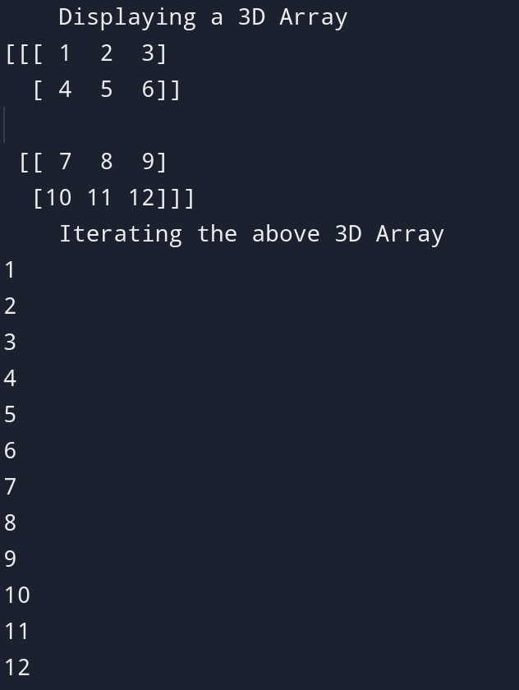

***Implements 5 Numpy functions :***

***Code:***

import numpy as np

print("\n")

print("*******************************************")

print(" Types of Array")

array_1d = np.array([1, 2, 3, 4, 5])

array_2d = np.array([[1, 2], [3, 4], [5, 6]])

array_3d = np.array([[[1, 2, 3], [4, 5, 6]], [[7, 8, 9], [10, 11, 12]]])

print("1D Array:")

print(array_1d)

print("\n2D Array:")

print(array_2d)

print("\n3D Array:")

print(array_3d)

print("*******************************************")

print("\n")

print("*******************************************")

print(" Array Properties")

print("\nShape of 2D Array:", array_2d.shape)

print("Number of Dimensions of 3D Array:", array_3d.ndim)

print("Size of 1D Array:", array_1d.size)

print("*******************************************")

print("\n")

print("*******************************************")

print(" Array Reshaping")

reshaped_array = array_2d.reshape(2, 3)

print("\nReshaped 2D Array (to shape (2, 3)):")

print(reshaped_array)

print("*******************************************")

print("\n")

print("*******************************************")

print(" Mathematical Operations")

array_a = np.array([1, 2, 3])

array_b = np.array([4, 5, 6])

print("\nElement-wise Addition:")

print(array_a + array_b)

print("\nElement-wise Multiplication:")

print(array_a * array_b)

print("*******************************************")

print("\n")

print("*******************************************")

print(" Statistical Functions")

print("\nMean of array_a:", np.mean(array_a))

print("Standard Deviation of array_a:", np.std(array_a))

print("Sum of elements in array_a:", np.sum(array_a))

print("*******************************************")

print("\n")

print("*******************************************")

print(" Indexing and Slicing")

print("\nSlicing 1D Array (first 3 elements):", array_1d[:3])

print("Slicing 2D Array (first row):", array_2d[0])

print("*******************************************")

***Output:***

